1. Find the derivatives of each of the following functions.

a. (3 pts) 

b. (3 pts) 

c. (4 pts) 

2. Evaluate the following limits if they exist.

a. (5 pts) 

b. (5 pts) 

3. a. (2 pts) Use a linear approximation to estimate the number .

b. (2 pts) Is your approximation an overestimate or an underestimate? Explain (Hint: You may want to

study the concavity of a function near the point ).

4. (10 pts) A spherical snowball is melting. Its radius is decreasing at 0.1 centimeters per hour when the radius is 20 cm.

How fast is the volume decreasing at this time? 

5. (10 pts) You have been asked to design a can in the shape of a right circular cylinder that will hold 1000 of apple

juice. Find the dimensions (the radius and height ) that will require the least amount of material. Justify your

answer.

Surface Area:  Volume: 

6. The Riemann definite integral $\int_{a}^{b}{f\left(x\right)dx}$ is defined as a limit of Riemann sums. The definite integral can be

*approximated* by a finite sum:

$$\int_{a}^{b}{f\left(x\right)dx}≈f\left(x_{1}^{*}\right)∆x+f\left(x_{2}^{*}\right)∆x+…+f\left(x_{n}^{*}\right)∆x$$

where $∆x=\frac{b-a}{n}.$ A function *f(x)* is given by the graph below. Answer the following questions.

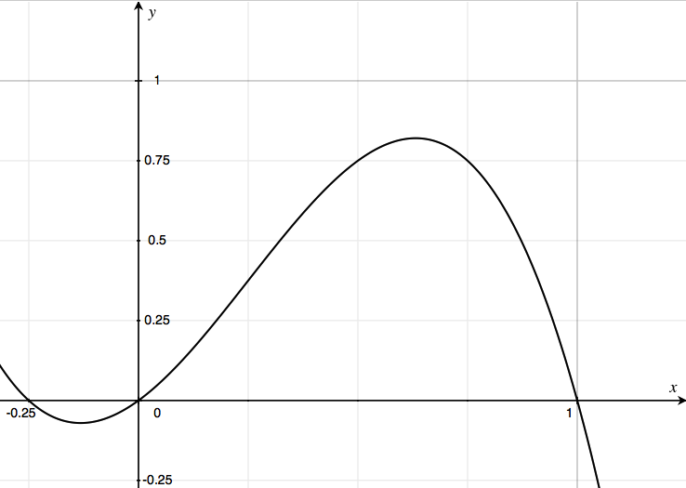

a. (2 pts) Imagine you want to estimate $\int_{0}^{1}{f\left(x\right)dx}$ using a Riemann sum with four subintervals. Illustrate the

four subintervals on the graph above. Calculate $∆x$.

b. (2 pts) The points $x_{1}^{*}, x_{2}^{*}, x_{3}^{*}, and x_{4}^{*}$ are called *sample points*. Suppose you choose the sample points to be

right endpoints. Illustrate the sample points on the graph above.

c. (2 pts) Illustrate ${f(x}_{1}^{*}), {f(x}_{2}^{*}), {f(x}_{3}^{*}), and {f(x}_{4}^{*})$ on your graph. Explain in words how to interpret these values.

d. (2 pts) The exact value of the definite integral is given by $\lim_{n→∞}{\sum_{i=1}^{n}{f\left(x_{i}^{*}\right)∆x}}$. Explain in words what

the limit means. (Hint: talk about rectangles)

e. (2 pts) Suppose *f(x)* is the velocity of a toy car inat time  seconds. Estimate the net change in position of

the car during the one-second time interval  by using rectangles with your *sample points* in part b.

7. Evaluate the following definite integrals or indefinite integrals.

a. (3 pts) 

b. (3 pts) 

c. (4 pts) 

8. (10 pts) Use calculus to sketch the graph of the following function. Show clearly the  and coordinates of all

local maximum, minimum, and inflection points. Show all asymptotes with dashed lines. Show all  and 

intercepts. Show the concavity clearly on the graph.



9. Let , whereis the function given in the graph below.

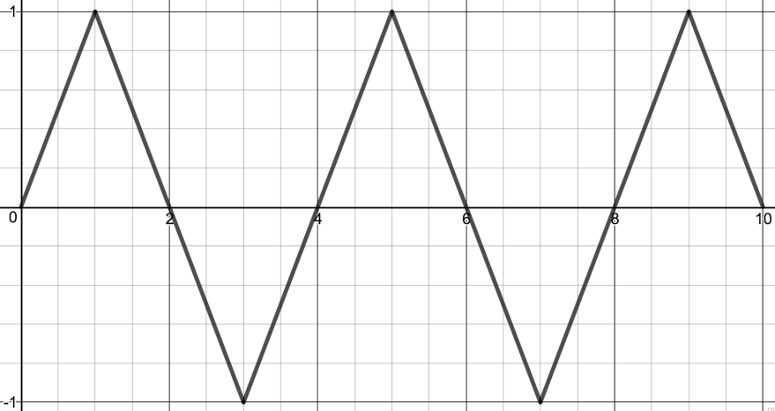

a. (2 pts) Identify all local maximum values of ** in the closed interval . Explain how you know you’ve

found a local maximum.

b. (2 pts) Identify all local minimum values of *g* in the closed interval . Explain how you know you’ve

found a local minimum.

c. (6 pts) Sketch a graph of the function . Show the concavity and inflection points clearly on your graph.

Show the exact (x,y) coordinates of all local max, local min, and inflection points.

10. Indicate whether each of the following statements is either true or false. If true, explain how you know. If it is

False, explain how you know and provide a counterexample. (A counterexample is an example that shows the

statement is false.)

a. (2 pts) The value of $\int_{1}^{0}{f\left(x\right)dx}$ must be negative, for all functions *f*.

b. (2 pts) If a < b < c, then $\int_{a}^{c}{f\left(x\right)dx=\int_{a}^{b}{f\left(x\right)dx+}\int_{b}^{c}{f\left(x\right)dx}}$. Draw a picture to show why it is true or false.

c. (2 pts) If, then  must have a local minimum at .

d. (2 pts) If , then has a local minimum or local maximum at.

e. (2 pts) If  is defined, then .

Math 150 Final Exam

San Diego State University

Saturday, December 17, 2016

|  |  |  |
| --- | --- | --- |
| Problem | Points | Points Possible |
| 1 |  | 10 |
| 2 |  | 10 |
| 3 |  | 10 |
| 4 |  | 10 |
| 5 |  | 10 |
| 6 |  | 10 |
| 7 |  | 10 |
| 8 |  | 10 |
| 9 |  | 10 |
| 10 |  | 10 |
| Total |  | 100 |

Name:_________________________________

TA Name: _________________________________ Section:________

**Show** **All** of your work. No work shown = 0 points!

**Box** **All** of your answers, We will not hunt for them.

**READ** the directions, and make sure you answer the question that is asked.

**Please** sign below:

I, the undersigned, hereby pledge that all work on this examination is my own. I have

neither given assistance to any other student, nor received assistance from any other

student. I understand that cheating on this examination will result in a failure as well

as being reported to San Diego State University’s Division of Academic Affairs.

Signature:_________________________________