1. Evaluate the following limits if they exist. If there is an infinite limit, determine the infinity ( or ).

(5 pts each part ) Show your work on all questions!

a. 

b. 

c. 

d. Let  Find 

e. 

f. 

2. (5pts) Sketch the graph of a function that satisfies all of the given conditions.

, , , 

3. (5 pts) Find a value for  that makes the function continuous on . Show the relevant calculations.



4. (10 pts) Use the Intermediate Value Theorem to show that the equation  has a solution

in the interval . Make sure you show that all the conditions of the IVT are satisfied. Note: You do

not need to find the value  of the solution, simply show that it exists by using the IVT.

5. (10 pts) Indicate whether each statement is **True or False**. If the statement is true, explain how you know it is true. If it is false, give a counterexample and explain why it is a counterexample. (A counterexample is an example that shows the statement is false.)

a. The graph of a function can have at most two horizontal asymptotes.

b. If a rational function has (x-1) in the denominator, then it has a vertical asymptote at x=1.

c. Ifis continuous at , then cannot be infinity.

d. If  is defined, then .

e. If  for all  and , then  never equals 0.

6. (10 pts) Match each of the graphs of the function (a) - (d) with the graph of its derivative (i) – (iv).

For each function write the corresponding number (i)-(iv) of the derivative on the line below.

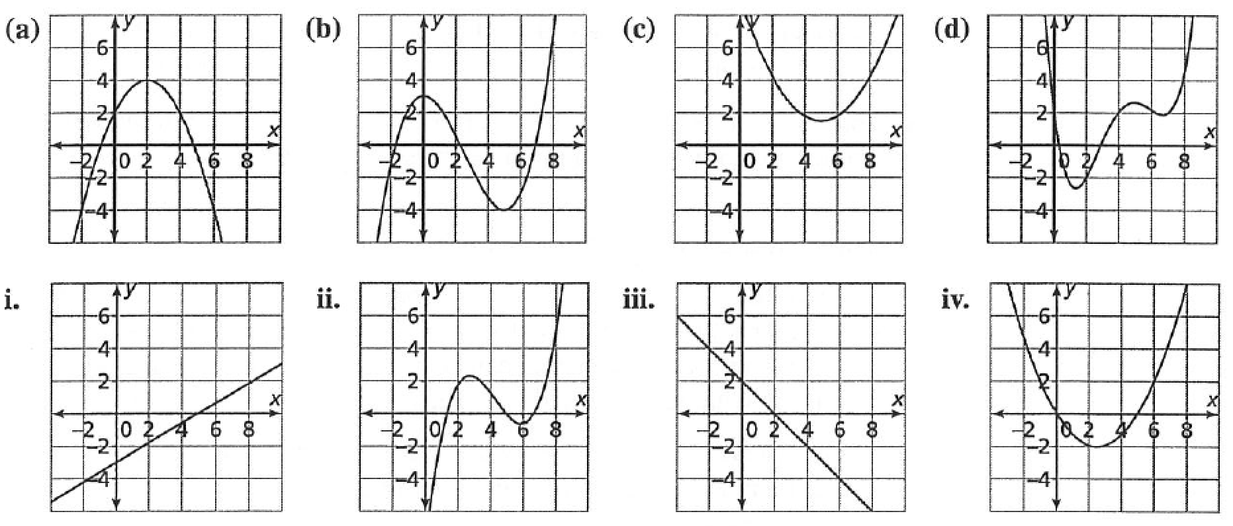

|  |  |  |  |  |
| --- | --- | --- | --- | --- |
| Function | (a) | (b) | (c) | (d) |
| Derivative | ________ | ________ | ________ | ________ |

7. (10 pts) Find the derivative of the function using the **definition of the derivative**. You will have to use limits here

so there will be no credit for using the short cut derivative rules. 

8. (10 pts) Differentiate the functions. You may use the shortcut rules here.

a. 

b. 

c. 

9. (10 pts) The equation of motion for a particle is , where  is in meters and  is in seconds.

a. Find the velocity as a function of . You may use the shortcut differentiation rules here.

b. Find the instantaneous velocity at time  seconds.

c. Find the equation of the tangent line to the graph of at .

Math 150 Exam 1

San Diego State University

Wednesday, October 5, 2016

|  |  |  |
| --- | --- | --- |
| Problem | Points | Points Possible |
| 1 |  | 30 |
| 2 |  | 5 |
| 3 |  | 5 |
| 4 |  | 10 |
| 5 |  | 10 |
| 6 |  | 10 |
| 7 |  | 10 |
| 8 |  | 10 |
| 9 |  | 10 |
| Total |  | 100 |

Name:_________________________________

TA Name: _________________________________ Section:________

**Show** **All** of your work. No work shown = 0 points!

**Box** **All** of your answers, We will not hunt for them.

**READ** the directions, and make sure you answer the question that is asked.

**Please** sign below:

I, the undersigned, hereby pledge that all work on this examination is my own. I have

neither given assistance to any other student, nor received assistance from any other

student. I understand that cheating on this examination will result in a failure as well

as being reported to San Diego State University’s Division of Academic Affairs.

Signature:_________________________________